YAESU REMOTE KEYPAD RESISTOR VALUES

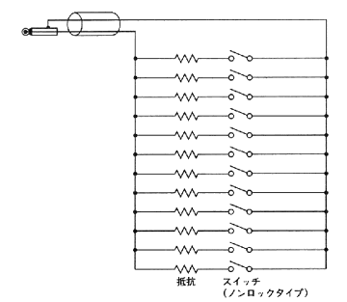

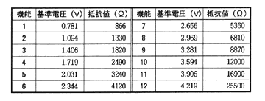

Thanks to Charlie Ho, VR2XMT for the info:

http://vr2xmt.blogspot.com/search?updated-min=2008-01-01T00%3A00%3A00%2B08%3A00&updated-max=2009-01-01T00%3A00%3A00%2B08%3A00&max-results=29

